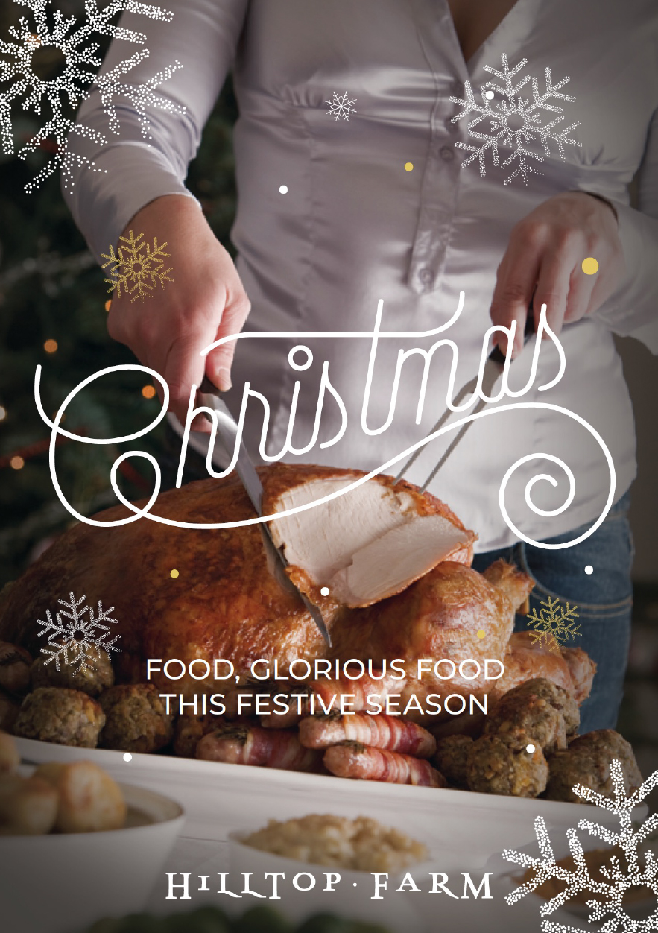

•

•

•

WHEN ONLY THE VERY BEST WILL DO


From our farm to your table

Serve up something special this Christmas with the finest quality meats and produce from Hilltop Farm. Local, fresh and reared to exceptionally high standards, for a difference you can really taste.

From premium free-range turkeys to our home-grown lamb and beef, speciality game, homemade pies and cured gammon. Outdoor-bred and fed, our approach ensures our animals are healthy and happy and the meat is of the finest quality. We really can’t be matched on flavour. We have options for veggie and vegan diners too, as well as savoury treats, speciality cheeses and perfect puds.

Pre-order everything you need to make the festive season that bit easier - and pick up any extras from the Farm Shop when you come to collect your order, our shelves will
be brimming.

FURTHER AFIELD?

We’re super excited to be able to deliver our gorgeous meats all over the UK this Christmas, with a range of delicious and deluxe hampers
to bring the finest Warwickshire produce straight to your door.

OUR FAMILY FARM

The Ellis family have farmed
the land here at Hilltop for four generations, employing the highest standards of animal welfare and environmental care to produce the very best food.

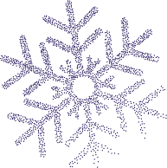

We take huge pride in selling our produce direct to our customers, and to supporting other local producers who share the same exceptionally high standards and husbandry as our own. All meats are farm assured and have full traceability. From our farm to your Christmas table.



CHRISTMAS FOOD
ORDER FORM



Simply fill in in the order form contained in this leaflet, save it with your name as the filename and then email the completed form to butchery@hilltopfarmshop.com. A £20 deposit is required to secure your order and can be paid in the shop, or over the phone with a credit/debit card. Last date for orders to ensure availability is Friday 5th December 2025 but if you miss the deadline please still get in touch and we’ll do our very best to help. Our farm shop is open Monday-Thursday 09:00–17:00, Friday & Saturday 08:30–17:00 and
Sundays 08.30–16:00.

the Ellis Family

YOUR DETAILS
Who is the best person to get in touch with if we need to discuss your order?
First name Surname

Mobile number Email address

COLLECTION
What date would you like to collect your order? Please tick one only.

22nd December

23rd December

24th December
Moseley Farmers Market


OFFICE USE ONLY

Deposit paid: Date paid:
£
DD/MM/YYYY
£ : / /

POULTRY & GAME
Sourced from south of Stratford-upon-Avon, our Whole Turkeys are free-range and able to forage around in the fields, allowing the birds to develop their flavour and much firmer meat with real texture. These are ‘Golden Turkeys’, which guarantees they are grown slowly to full maturity and fed on a natural diet.
They are also dry-aged for at least seven days to bring out the full flavour. Our Turkey Breasts are sourced from Adlington, slowly grown, naturally fed and high welfare. Our Chicken is always free-range - birds reared in a natural environment for an exceptionally succulent taste.

Item | Weight | Serves | Price | Weight/quantity*
Local free range turkey | 4.5-5kg | 6-8 | £96
Local free range turkey | 5-5.9kg | 8+ | £101
Local free range turkey | 6-6.9kg |  | £106
Local free range turkey | 7-7.9kg |  | £116
Local free range turkey | 8-8.9kg |  | £126
Local free range turkey | 9-9.9kg |  | £136
Local free range turkey | 10-10.9kg | 12+ | £146
Local free range turkey | 11-11.9kg |  | £151
Local, boneless turkey breast | 2-3kg | 6-8 | £17.85 per kg
Local, boneless turkey breast | 4-6kg | 12+ | £17.85 per kg
Local, boneless turkey breast (stuffed with apple & cranberry sausage) | 1.5kg | 2-4 | £49.20 each
 | 3kg | 6-8 | £91.35 each
Local free range chicken | 1.5-2.4kg | 4-6 | £8.15 per kg
Local free range cockerel | 3.5-5kg | 8 | £14.25 per kg
Local free range duck | 2-3kg | 2-3 | £9.60 per kg
Free range goose | 4-6kg | 4-8 | £22.85 per kg
Local pheasant brace (1 cock / 1 hen) |  | 3-4 | £8.50 per brace
*All weights are approximate

CHRISTMAS MEAT HAMPERS
Put together by our expert butchers, our hampers provide a fantastic selection of festive favourites. Crafted with the same high standards as our core range, ensuring that every cut of meat is locally sourced and of premium quality.

Item | Description | Price | Quantity*
Christmas day meat hamper | Christmas day sorted with our Hilltop meat hamper! With a turkey breast, smoked gammon and plenty of pigs in blankets, your Christmas Day spread won’t be lacking! Serves 4-6 people.  - 2kg turkey breast  - 2kg dry cured gammon joint  - 1 x 500g pork sausage meat  - 8 rashers smoked streaky bacon  - 1 Christmas pork pie  - 500g pack pigs in blankets | £75:00
‘All the trimmings’ bundle | Our ‘All the trimmings’ bundle has all those little extras to really make your Christmas Day lunch extra special. Serves 4-6 people.  - Turkey Madeira & sage gravy  - Jolly Fine stuffing  - Christmas pork pie  - Real Ale chutney  - Cranberry sauce  - 8 x rashers streaky bacon  - Farmhouse sausage meat  - 1 x tray pigs in blankets | £35.00


GRASS FED 28-DAY MATURED BEEF
Grown on our own farm here in Hunningham or sourced locally from known and trusted farmers. We rear old English and Scottish breeds the traditional way, slow maturing on permanent pastures. It’s a method that ensures both exceptionally high welfare and exceptionally great taste. Grass fed during the warmer months and supplemented with home grown peas, beans and barley in the winter. Our Beef is matured for a minimum of 28 days to make it as succulent, tender and as full of flavour as possible.

Item | Price | Quantity/weight*
Rolled joint of best Sirloin (2kg serves approx 8) | £33.00 per kg
Boned & rolled rib of beef (2kg serves approx 8) | £32.00 per kg
French trimmed rib (2kg serves approx 4-6) | £34.00 per kg
Rib on the bone (2kg serves approx 6-8) | £30.00 per kg
Topside (2kg serves approx 6-8, 4kg serves 8) | £17.00 per kg
Fillet of beef (1kg serves approx 4-6) | £68.00 per kg
Brisket (2kg serves approx 6-8) | £16.00 per kg
Slow roast joint (2kg serves approx 6-8) | £16.00 per kg
Silverside salmon cut (2kg serves approx 6-8) | £17.00 per kg

VENISON
Locally sourced from Warwickshire, wild venison. Seasonality and sustainability at its best – and full of flavour.
Item | Price | Quantity/weight*
Haunch of venison (1kg serves 4, 2kg serves 6-8) | £16.00 per kg
Loin of venison (1kg serves max 4) | £30.00 per kg
Diced venison (1kg serves 4, 2kg serves 6-8) | £12.00 per kg
Steaks (approx 225g per person) | £24.00 per kg

GRASS FED LAMB
Grown on our own farm here in Hunningham or sourced locally from known and trusted farmers. Grass fed during the warmer months and supplemented with home grown peas, beans & barley in the winter. Our lamb continues to be as popular today as it ever was - tender, juicy and ethically reared.

Item | Price | Weight/quantity*
Loin of lamb (1kg serves 4-5) | £28.80 per kg
Leg on the bone (1kg serves 4-5) | £18.80 per kg
Leg, boned and rolled (1-1.5kg serves 4-5) | £20.80 per kg
Whole shoulder (0.5kg serves 2-3, 1kg serves 4-5) | £15.80 per kg
Shoulder boned and rolled (1kg serves 4-5) | £17.80 per kg
Rack of lamb (2 x 4 ribs serves 2) | £32.50 per kg

PORK
Our pigs are sourced from Packington, where they are reared to the very highest welfare standards and have been well recognised by butchers and the RSPCA Freedom Foods, as the best you can get.
Item | Price | Weight/quantity*
Free range leg of pork on the bone | £9.50 per kg
Free range, leg of pork boned and rolled | £11.80 per kg
Free range shoulder, boned and rolled | £9.00 per kg
Free range loin, on the bone | £9.50 per kg
Free range loin, boned & rolled | £10.80 per kg
Free range pork spare rib | £9.50 per kg
Dry cured whole cooked ham, off the bone (min 1kg) | £14.25 per kg
Dry cured sliced ham (4 slices per pack) | £4 per pack approx

PORK CONT/D

Item | Price | Weight/quantity*
Free range pork sausage meat (500g pack) | Free range £4 each
Free range pork sausage meat (500g pack) | Farmhouse £4 each
Handmade sausages (500g pack approx) | Chipolatas £10.99 per kg
Handmade sausages (500g pack approx) | Farmhouse £10.99 per kg
Handmade sausages (500g pack approx) | Free range £10.99 per kg
Pigs in blankets: Chipolatas wrapped in streaky bacon (500g pack) | £16.25 per kg

GAMMON
Cured here at Hilltop Farm, using traditional methods to give you an excellent tasting gammon.

Item | Price | Weight/quantity*
Dry cured gammon  (3-5kg serves 8-12, 5-6kg serves 12-16) | Smoked £14.30 per kg
Dry cured gammon  (3-5kg serves 8-12, 5-6kg serves 12-16) | Unsmoked £13.75 per kg
Traditional dry cured black gammon (3-5kg serves 8-12, 5-6kg serves 12-16) | Molasses & honey smoked over hickory & oak £17.95 per kg

FISH
We source only the highest-quality salmon in our products to ensure that every bite is sustainably produced, and absolutely delicious.

Item | Price | Weight/quantity*
Yorkshire Mild Oak Smoked Salmon  (100g pack) | £5.10 each
Gin Botanical Sashimi Smoked Salmon  (100g pack) | £5.25 each
Gravadlax Sashimi Smoked Salmon  (100g pack) | £5.25 each
Yorkshire Mild Smoked Salmon side | £35.65 per kg



SPECIALITY PIES, SCOTCH EGGS & SAUSAGE ROLLS

Pork pies available for collection from 22nd December, if you would like to order for an earlier collection, please speak to a member of the Team. These hand finished pork pies are made to Maggie Topping’s original homemade family recipes – using only the highest quality locally sourced ingredients for an award-winning taste and freshness.

Item | Price | Weight/quantity*
Traditional pork pie  (medium 430g, large 980g) | Medium £4.75 each
Traditional pork pie  (medium 430g, large 980g) | Large £12.75 each
Christmas pork pie with pork, chicken, apricot & cranberry (450g) | £6.50 each
Christmas Hunstman pork pie. Pork & chicken pie topped with onion & sage stufﬁng (500kg) | £6.75 each
Hilltop Farm homemade free range scotch egg (plain pork) | £3.85 each
Turkey, bacon & cranberry free  range scotch egg | £3.85 each
Hilltop Farm homemade sausage rolls | Small £2.10 each
Hilltop Farm homemade sausage rolls | Large £4.00 each
Turkey, bacon & cranberry garland | £12.50 each
Turkey, bacon & cranberry sausage roll | £2.75 each
Hog roast sausage roll | £2.60 each
Mediterranean vegetable & feta roll (V) | £2.60 each

PATE
These pates are hand-made in small batches to ensure a wonderful texture and flavour in every pot.

Item | Price | Quantity*
Findlater’s chicken liver pate (120g) | £3.75 each
Findlater’s venison pate (120g) | £3.75 each
Findlater’s duck pate (120g) | £3.75 each
Findlater’s mackerel pate (120g) | £3.99 each
Findlater’s smoked salmon pate (120g) | £3.99 each

CHEESE
We have a wide selection of cheese available on our cheese counter which will be open every day, so for more cheeses, please pop in and see us. Christmas classics are below.

Item | Price | Weight/quantity*
Simon Weaver organic brie (1kg) | £15.00 each
Croome Cuisine The Festive fruity cheese (150g) | £3.30 each
Colston Bassett stilton (cut to size) | £21.95 per kg
Shropshire Blue (cut to size) | £21.95 per kg
Cornish Yarg (cut to size) | £24.95 per kg
Cornish Yarg wild garlic (cut to size) | £24.95 per kg
Godminster Star (150g) | £6.95 each
Snowdonia Black Bomber (200g) | £5.70 each
Snowdonia Green Thunder (200g) | £5.75 each
Greens of Glastonbury Twanger (200g) | £3.95 each
Little She ewes cheese (120g) | £6.95 each
Ragstone goats cheese (200g) | £7.15 each

QUICHE
Freshly baked here in our deli.

Item | Price | Quantity*
Brie, sun-blushed tomato & basil (medium) (V) | £6.25 each
Quiche lorraine (medium) | £6.25 each
Smoked salmon & crème fraiche (medium) | £7.25 each

PUDDINGS, MINCE PIES & CAKES
Our puddings, mince pies and cakes are all sourced from local brilliant bakeries who follow the same ethos as we do – the best ingredients, traditional methods and unbeatable taste.

Item | Price | Quantity*
Luxury Christmas Cake 6’’ iced, with Windmill Hill IPA soaked fruit and a generous brandy drizzle | £23.00 each
Fiona Cairns 7’’ mistletoe wreath fruit cake | £25.75 each
Fiona Cairns 5” iced Christmas holly wreath fruit cake | £12.90 each
Traditional hand-made mince pies (half dozen) | £4.75
Boozy Christmas pudding using Windmill Hills ﬁnest Stout and Porter (serves 6-8) | £23 each
Mincemeat frangipane tart, with all butter pastry, almond frangipane, icing and Christmas sparkle (serves 4) | £8.95 each
Biscoff Yule Log, light genoese chocolate sponge cake, with Biscoff and Belgian chocolate ganache (serves 4-6) | £14.50 each
Baileys Tiramisu Cheesecake, with a whipped coffee topping, Belgian chocolate shards and cocoa (serves 4-6) | £16.95 each

PUDDINGS, MINCE PIES & CAKES CONT/D

Item | Price | Quantity
Orange & Cranberry Meringue Tart, all butter pastry case with an orange custard and cranberry filling. Topped with snowy Italian meringue and cranberries (large serves 4-6, medium serves 4) | Large £16.95 each
 | Medium £8.95 each
Fiona Cairns Snowman cup cakes golden sponge (6 pack) | £7.50 per pack
Fiona Cairns Christmas pudding cup cakes chocolate sponge (6 pack) | £7.50 per pack

CHRISTMAS GIFT HAMPERS
We have something for everyone, from the sweet tooth, to the cheese lover! Plastic free, re-useable cardboard hampers make a great sustainable gifting option. View our full range of ready made hampers online at: www.hilltopfarmshop.com. Want to personalise the contents and build your own hamper? Then pop into the farm shop and we’ll get it all wrapped up.

Item |  | Price | Quantity
‘The Sweet Spot’ gift hamper | - JOY Jolly munch mix 100g  - Teonies dipped cranberry cookies 300g  - Curious curds chocolate orange jar 210g  - Bon Bons gourmet milk chocolate Brazils 130g | £25.00
‘The Cheese Lover’ gift hamper | - The Fine Cheese Company, Extra virgin olive oil & sea salt crackers 125g  - Bay Tress, Spicy gooseberry & coriander chutney 310g  - Tenuta Marmorelle, Figs & Nuts panforte 100g  - Croombe cuisine, The Bramble mature cheddar with cranberries, apple & blackberries 150g  - Snowdonia cheese company, Black bomber extra mature cheddar 200g  - Neal’s Yard Creamery, Finns soft cows cheese 200g. | £33.00
‘The Discerning Gentleman’ gift hamper | - Joy Box dark chocolate brazils 150g  - Joy pouch beer mix 60g  - Crispy crackled pork bites 65g  - Crazy Bastard Sauce Chipotle & Pineapple 100ml  - Original Cheese sables 35g | £28.00

CHRISTMAS OPENING TIMES

Date | Shop | Cafe
Christmas Eve 24th December | 08:00-15:00 | 08:00-15:00 Christmas eve brunch menu
Christmas Day 25th December | Closed | Closed
Boxing Day 26th December | Closed | Closed
27th December | 10:00-15:00 | 10:00-15:00
28th December | 09:00-16:00 | 09:00-16:00
29th December | 09:00-17:00 | 09:00-16:00
30th December | 09:00-17:00 | 09:00-16:00
New Year’s Eve 31st December | 09:00-15:00 | 09:00-15:00
New Year’s Day 1st January | Closed | Closed
2nd January | 09:00-17:00 | 09:00-16:00


O’ CHRISTMAS TREE
Take home a beautifully British-grown
Christmas tree. Choose from a wide
selection at the farm shop, with cut
and potted varieties, including the
very best non-drop Nordmann Firs.
Available early December.





AND A HAPPY NEW YEAR

Hilltop Farm Shop & Café Fosse Way
Hunningham Hill Warwickshire CV33 9EL

T. 01926 632978
E. butchery@hilltopfarmshop.com www.hilltopfarmshop.com

